Project Documentation
Date | 2 July 2026
Team ID | xxxx
Project Name | Smart Lender
Maximum Marks | 3 Marks

Project Title
Smart Lender – AI Powered Loan Eligibility Prediction System

1. Introduction
Smart Lender is a Machine Learning-based web application that predicts whether a loan applicant is eligible for a loan. The application analyzes financial information such as monthly income, credit score, loan amount, and years of employment to provide instant loan eligibility predictions.
The project uses the XGBoost classification algorithm, which was selected as the bestperforming model after comparing multiple machine learning algorithms. The application is developed using Python and Flask and provides a simple web interface for users to enter their details and receive a prediction.

2. Problem Statement
Banks and financial institutions receive a large number of loan applications every day. Manual evaluation of every application is time-consuming and may lead to inconsistent decisions.
This project aims to automate the initial loan screening process using Machine Learning, enabling faster, accurate, and data-driven loan eligibility predictions.

3. Objectives
- Develop a machine learning model for loan eligibility prediction.
- Compare multiple classification algorithms.
- Deploy the best model using Flask.
- Store applicant details in a database.
- Send prediction results to the applicant via email.
- Provide a simple and user-friendly interface.

4. Technologies Used
- Python
- Flask
- XGBoost
- Scikit-Learn
- Pandas
- NumPy
- HTML5
- CSS3
- SQLite
- Joblib
- Gmail SMTP
5. System Requirements

Hardware
- Intel i3 Processor or above
- 4 GB RAM (8 GB Recommended)
- 500 MB Free Storage

Software
- Windows 10/11
- Python 3.14
- Visual Studio Code
- Flask
- Jupyter Notebook
6. Dataset Description
The project uses a loan approval dataset containing applicant financial information.

Features
- Income
- Credit Score
- Loan Amount
- Years Employed

Target Variable
- Loan Approved
- Loan Rejected

7. Methodology
The project follows these steps:
- Dataset Collection
- Data Cleaning
- Exploratory Data Analysis
- Feature Selection
- Model Training
- Model Evaluation
- Model Saving
- Flask Application Development
- Prediction
- Database Storage
- Email Notification

8. Machine Learning Models
The following algorithms were trained and evaluated:
- Decision Tree
- Random Forest
- K-Nearest Neighbors (KNN)
- XGBoost
Among these, XGBoost achieved the highest performance and was selected for deployment.
9. System Architecture
User
│
▼
Web Application (Flask)
│
▼
Input Validation
│
▼
XGBoost Model
│
▼
Prediction
│
├────────► SQLite Database
│
└────────► Email Notification
│
▼
Prediction Result

10. Project Structure
SMART LENDAR/
│
├── .venv/
├── Dataset/
│ └── loan_approval.csv
├── eda_plots/
├── flask/
│ ├── static\css/
│ ├── templates/
│ └── .env ├── app1.py
├── loan_model.pkl
├── .gitignore
├── edaanalysis.py
├── loan_model.pkl
├── loans.db
├── modelbuilding.py
├── preprocess.py
├── test.py
└── train_model.py

11. Features
- AI-Based Loan Prediction
- Real-Time Prediction
- SQLite Database Integration
- Email Notification
- User-Friendly Interface
- Secure Environment Variables
- Responsive Web Design

12. Results
The application successfully predicts loan eligibility using the trained XGBoost model. User details are stored in the SQLite database, and prediction results are sent automatically to the registered email address.
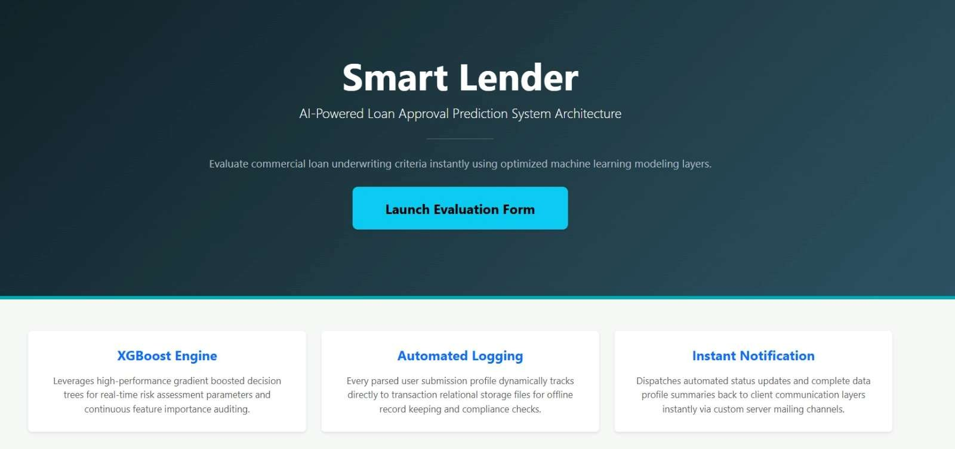

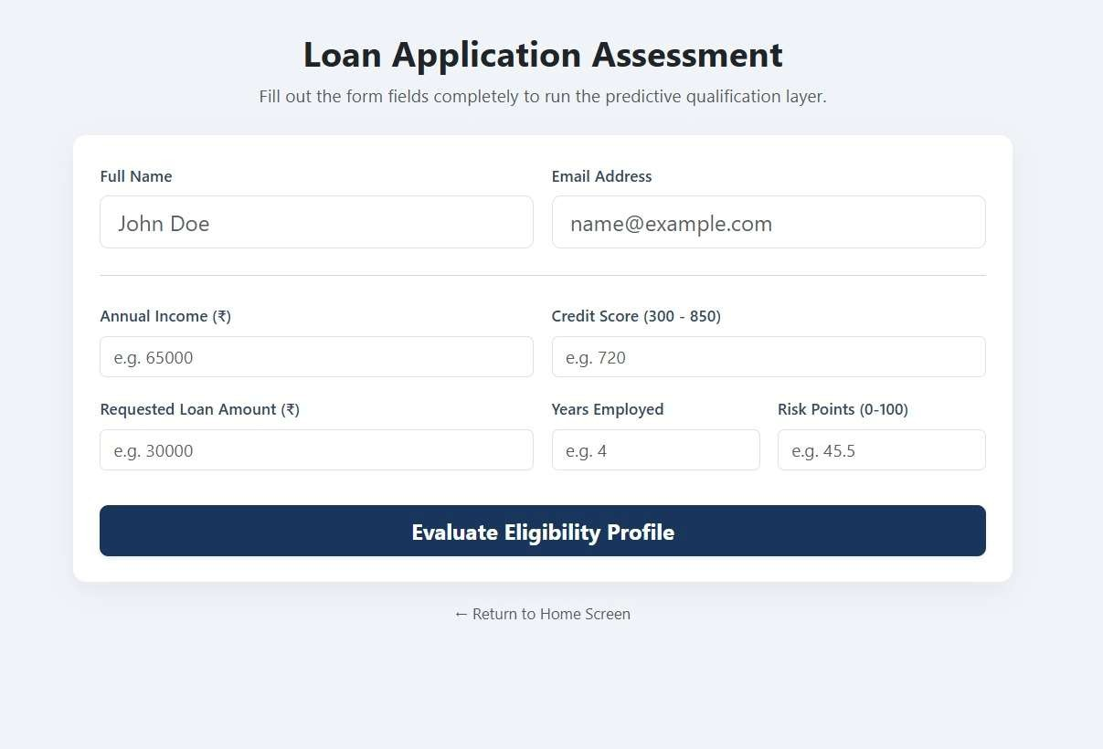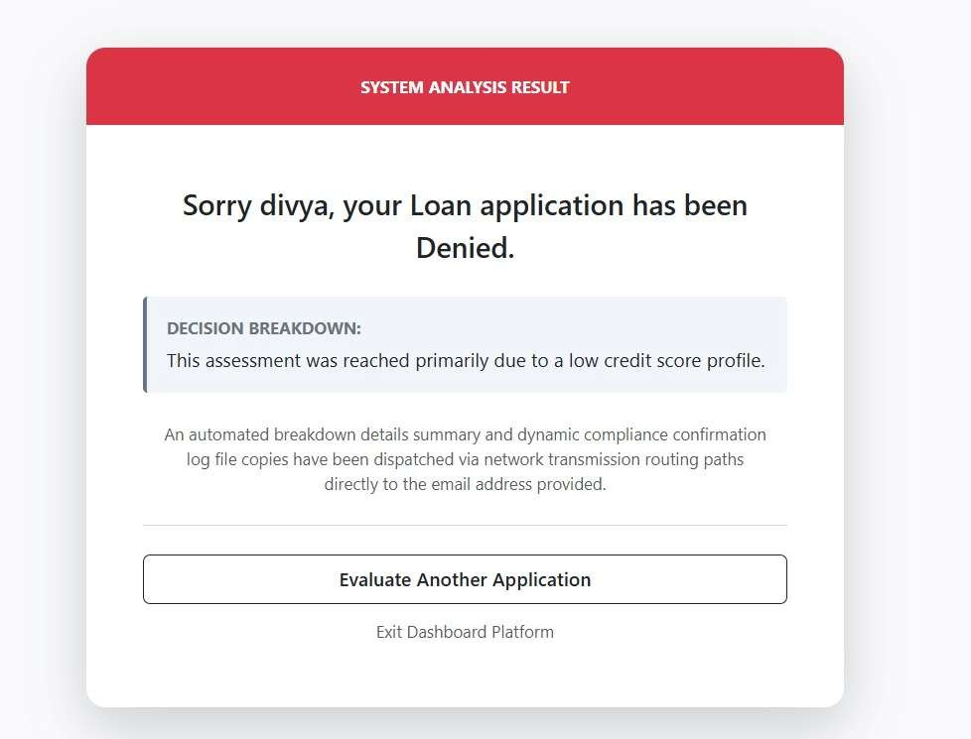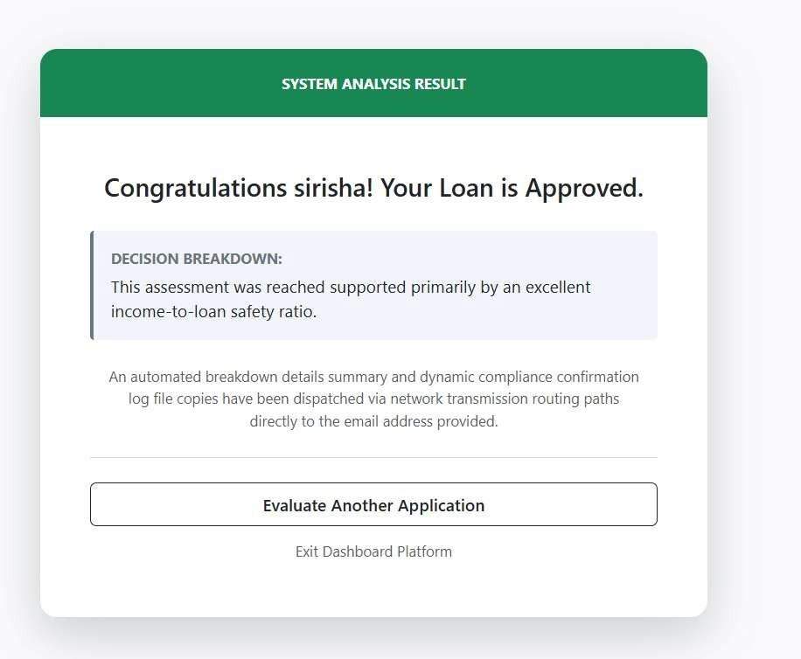

13. Future Enhancements
- Cloud Deployment (IBM Cloud/AWS/Azure)
- User Authentication
- Admin Dashboard
- Loan History Tracking
- PDF Report Generation
- Advanced Analytics Dashboard

14. Conclusion
The Smart Lender application demonstrates how Machine Learning can support financial institutions by automating loan eligibility prediction. By integrating XGBoost, Flask, SQLite, and email notifications, the project provides a complete end-to-end solution that is efficient, scalable, and user-friendly.

